**Abhidha Arya**

**Dimension and Fact (table) description and SQL snapshots:**

1. Tables Created: The highlighted part shows all the tables created.

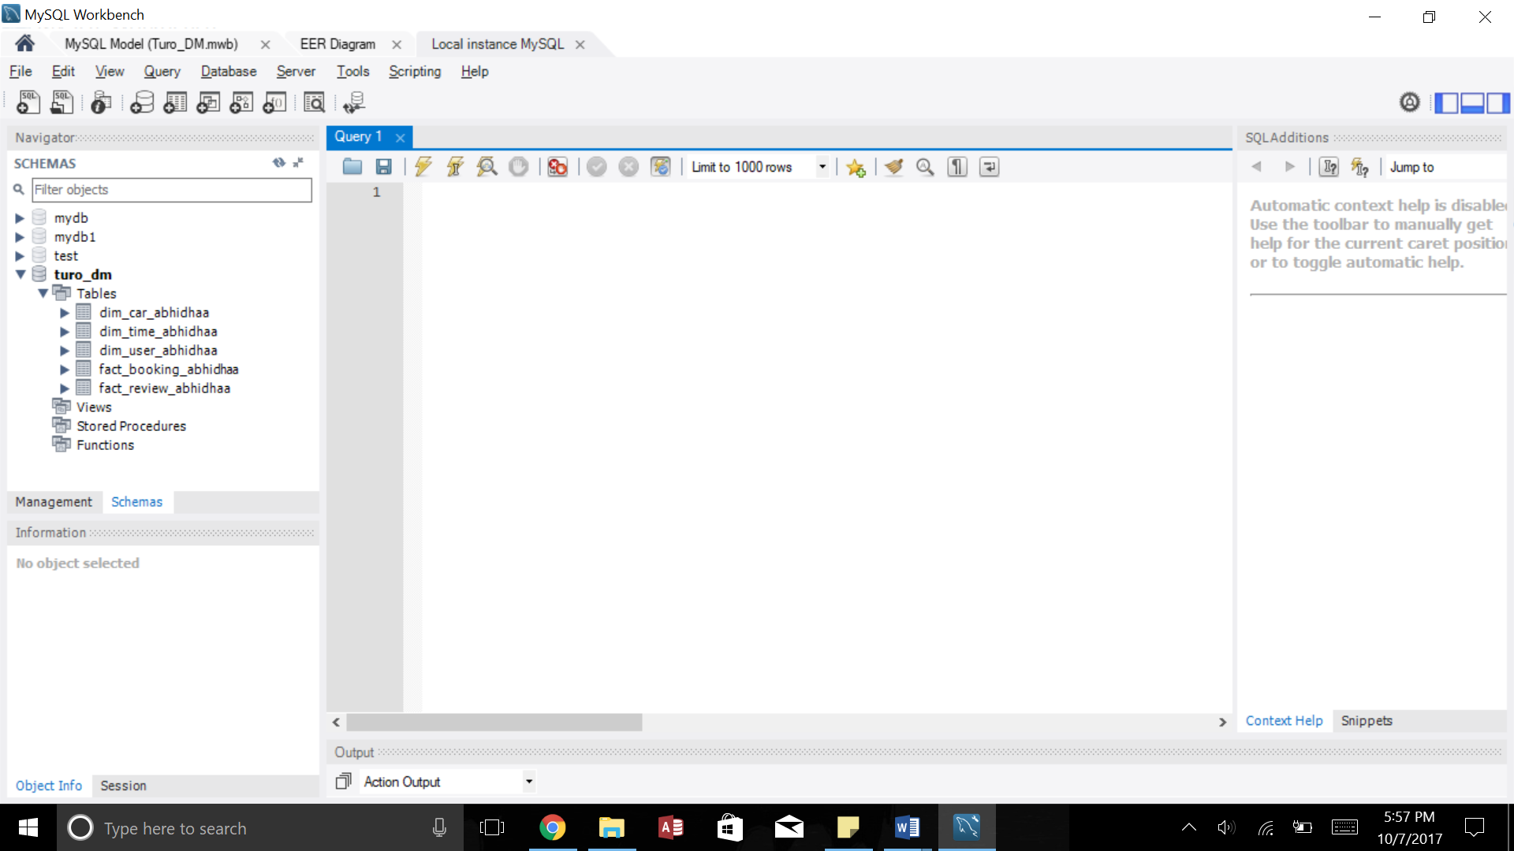

1. Dim_User_AbhidhaA: Provides the details of the user. The table needs to be aliased since it’s a role-playing dimension (User can be both a guest or a host).

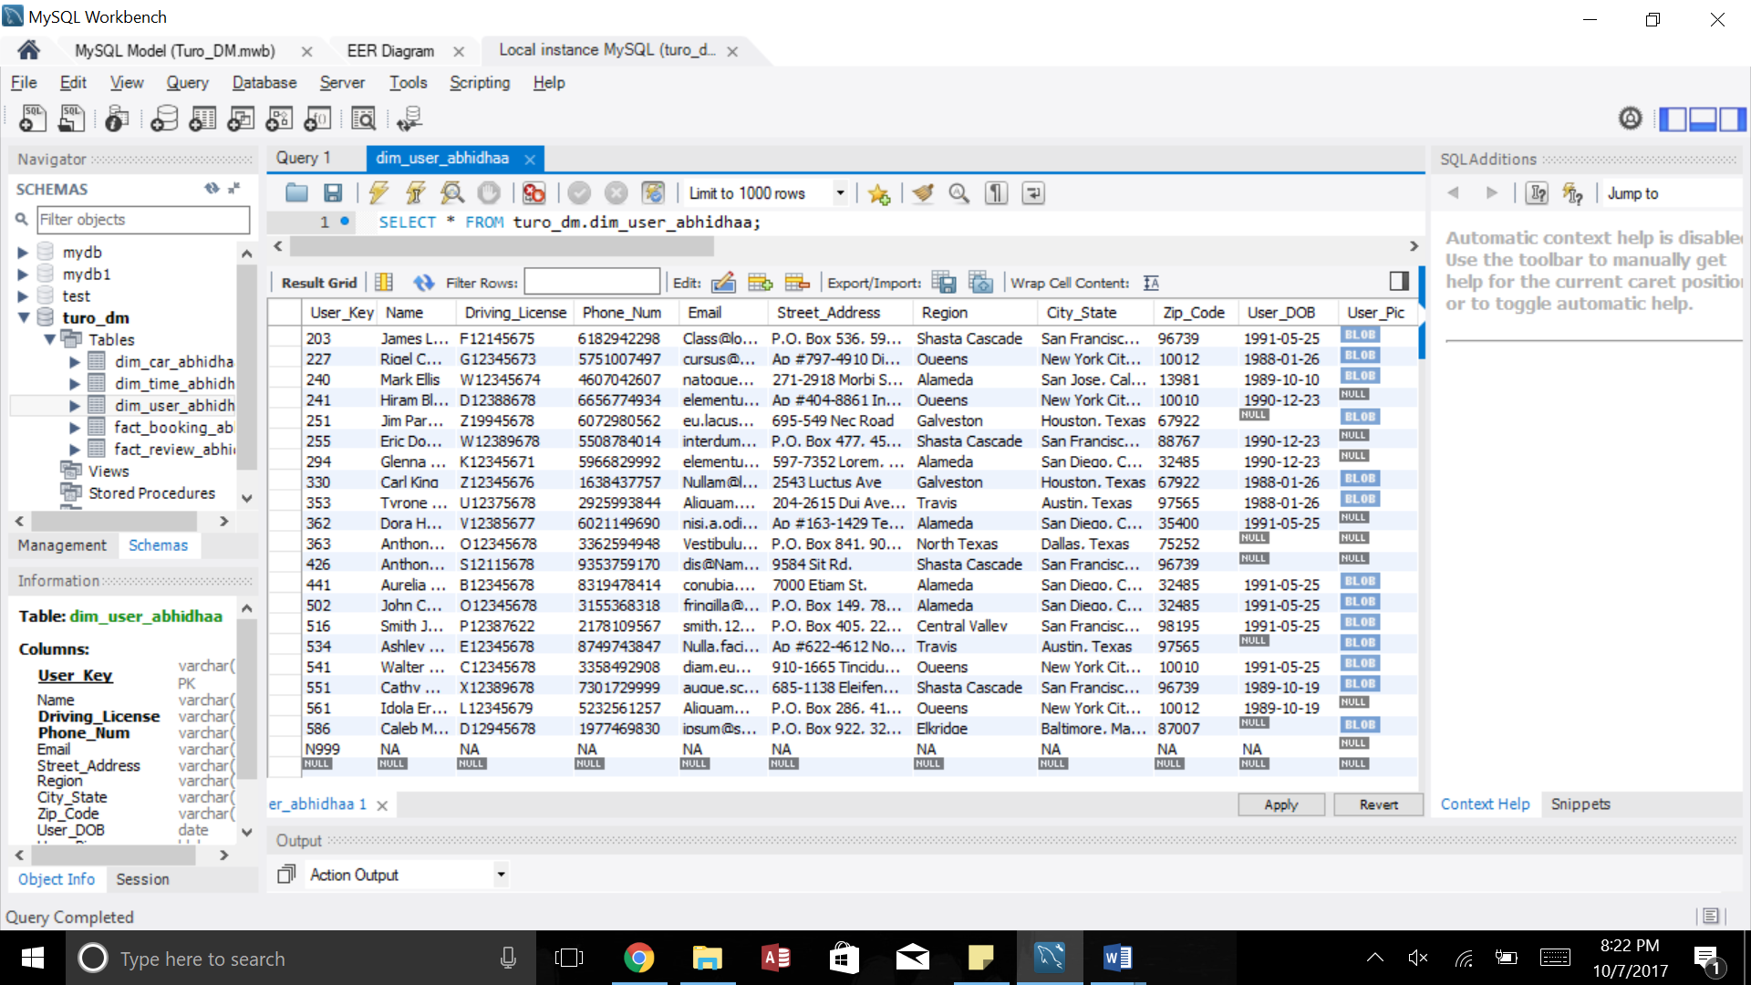

1. Dim_Time_AbhidhaA: Captures the date, month, quarter and the year.

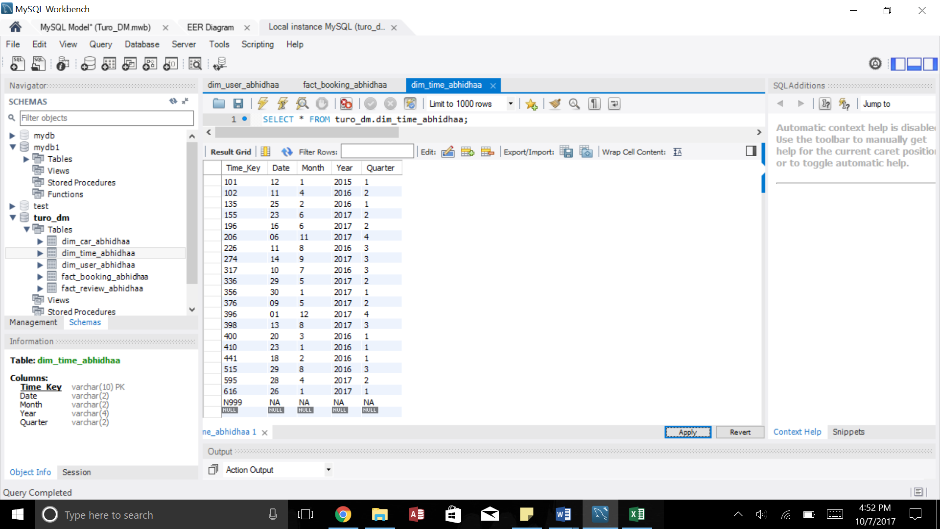

1. Dim_Car_AbhidhaA: Provides the details of the Cars listed.

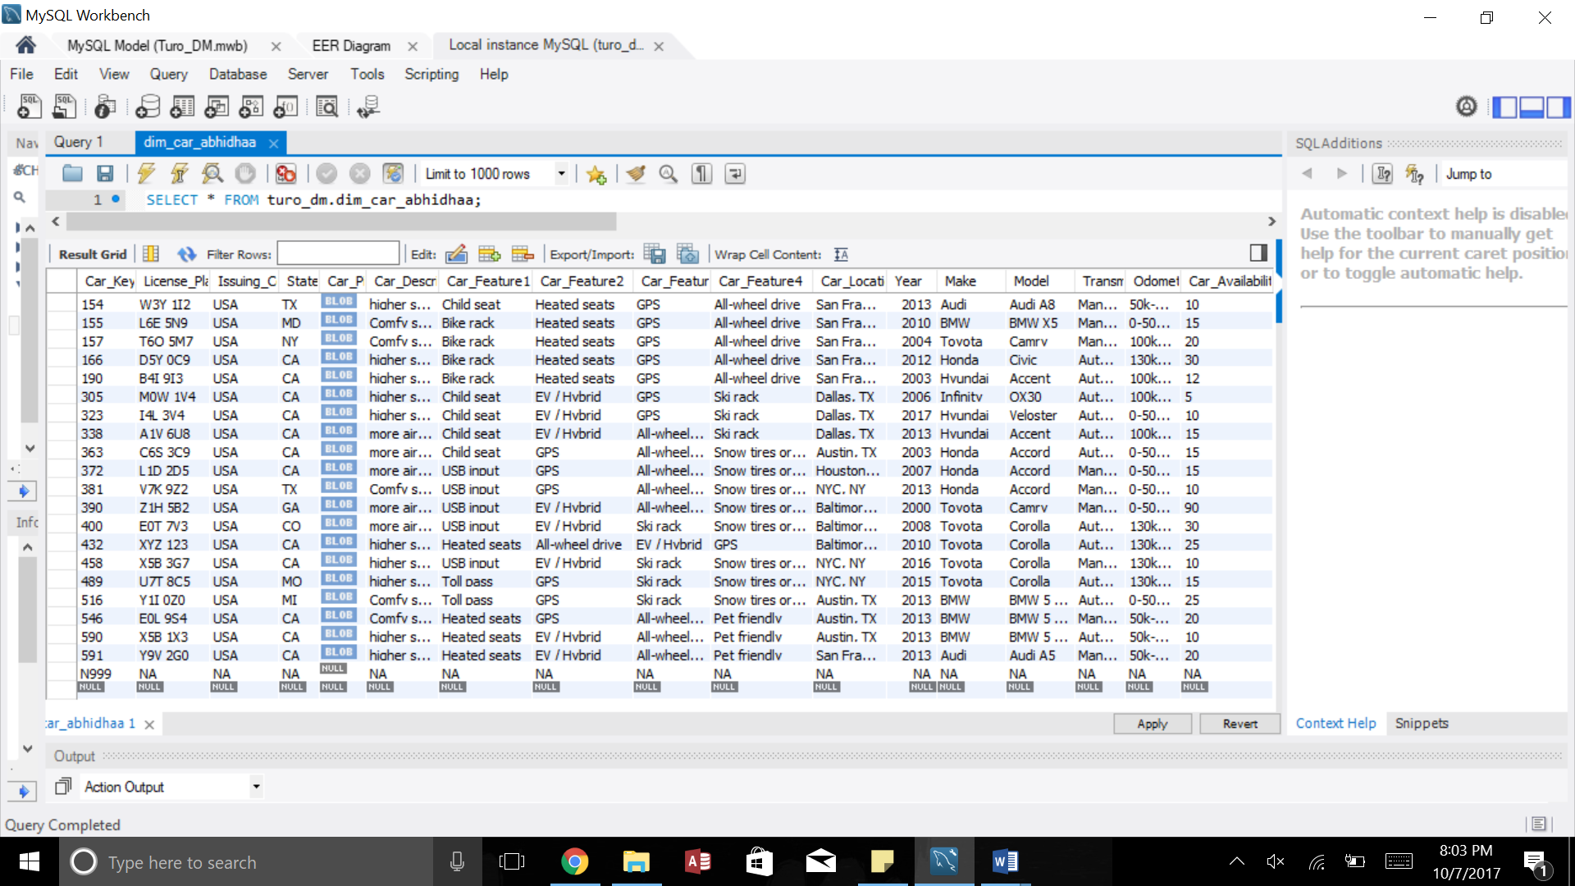

1. Fact_Booking_AbhidhaA: Captures the booking transactions; booking per guest by the city, by zip code, by region, per car, per month. The measures in this case are No. of days the car was booked and the Total amount paid for the trip. The hard coded 1 in column ‘X’ can be used to count the number of cars booked per guest when the reports are run by month.

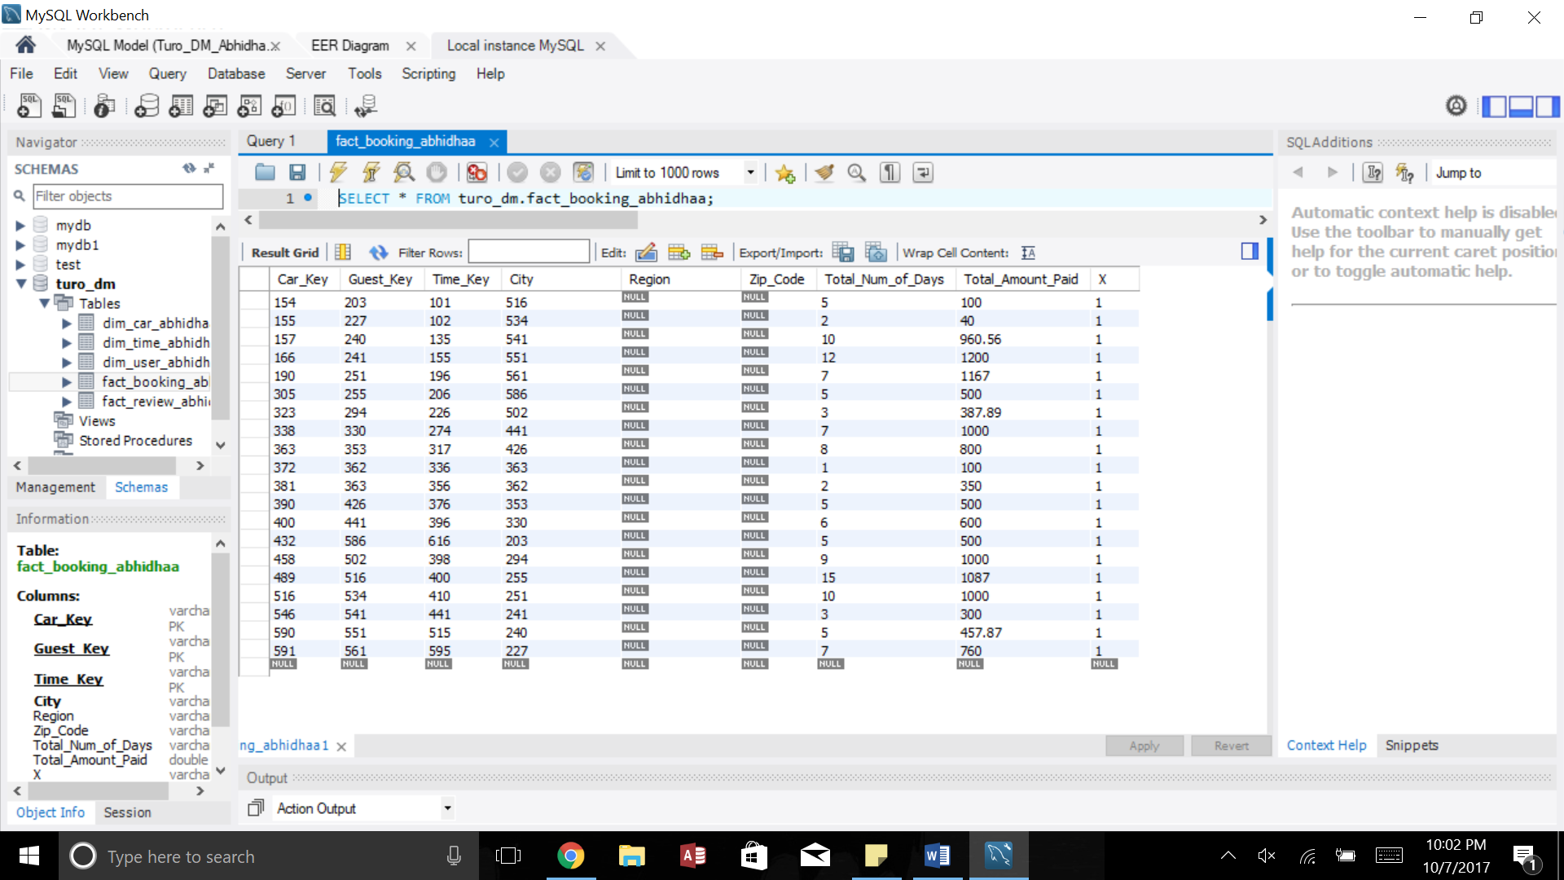

1. Fact_Review_AbhidhaA: Captures the feedback of the guests for the booked car and host; reviews per car, per guest, per host, per month.

